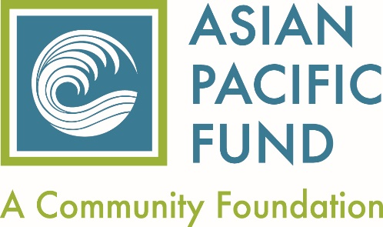

Asian Pacific Fund Affiliate & Associate Guidelines

The Asian Pacific Fund is a community foundation dedicated to strengthening the Asian American & Pacific Islander (AAPI) community in the Bay Area by increasing philanthropy and supporting organizations that serve our most vulnerable community members.

Be becoming an Affiliate Member or an Associate Member (see Affiliate Organization Requirements below) of the Asian Pacific Fund, we offer the following benefits to strengthen your organization and support your work:

AFFILIATE Organization Benefits:
- Eligible for Asian Pacific Fund grant programs
- Eligible for grants made in consultation with individual private donors
- Notifications of funding opportunities that become available
- Consultation and assistance on working with private donors
- Workshops and trainings on capacity building or relevant issues facing the AAPI populations you serve
- Quarterly e-newsletter which focuses on current issues facing the AAPI community

Affiliate Organization Requirements

I. Committed to serving the AAPI community by;
- Providing information that the majority population, 51% or more, served by your organization is of Asian American and/or Pacific Islander descent ***
- Providing information that demonstrates your staff has expertise, cultural competence, language ability, etc. to deliver the services to underserved populations in the Asian American & Pacific Islander community

II. Programmatic Focus
Organization shall provide services, public education, or advocacy in any of the following areas:
- Youth or the elderly
- Health & human services
- Education
- Environmental conservation
- Economic development
- Immigrant & legal services
- Culture and the arts
- Civic engagement

III. Geographic Focus
Organization (including headquarters) and program beneficiaries (clients, participants, audience) must be located in one of the 9 Bay Area counties: Alameda, Contra Costa, Marin, Santa Clara, San Mateo, San Francisco, Napa, Sonoma and Solano counties.

IV. Operational Status
- Must be a tax-exempt organization under Section 501(c)(3) of the Internal Revenue Code (Exceptions may be made for fiscally sponsored organizations that help us reach underrepresented populations)
- Have an annual operating budget of at least $50,000 for 3 consecutive years***
- Meets all applicable federal, state, and local registration & reporting requirements for not-for-profit organizations.

We recognize that there are many worthy organizations that may not meet all the criteria required for affiliate status and we invite you to join as an Associate Member.

***ASSOCIATE Organization Requirements

- Providing information that the population you serve, 45% or more, are AAPIs
- Programmatic focus same as listed for Affiliates
- Geographic focus same as listed for Affiliates
- Operational Status
- Must be a tax-exempt organization under Section 501(c)(3) of the Internal Revenue Code or be fiscally sponsored
- Have an annual operating budget of at least $50,000 for one year
- Meets all applicable federal, state, and local registration & reporting requirements for not-for-profit organizations

If you meet the above criteria, we invite to become an Associate Member of the Fund.
(Please note: Associate Members are not eligible for Asian Pacific Fund grants)

ASSOCIATE Organization Benefits:
- Eligible for grants made in consultation with individual private donors
- Notifications of outside funding opportunities that become available
- Consultation and assistance on working with private donors
- Workshops and trainings on capacity building or relevant issues facing the AAPI populations you serve
- Quarterly e-newsletter which focuses on current issues facing the AAPI community

Updated June 2022

