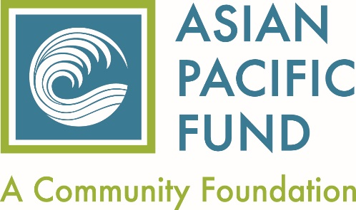

Asian Pacific Fund Affiliate Guidelines

The Asian Pacific Fund is a community foundation dedicated to strengthening the Asian & Pacific Islander community in the Bay Area by increasing philanthropy and supporting organizations that serve our most vulnerable community members.

Be becoming an Affiliate Member or an Associate Member (see Affiliate Organization Requirements below) of the Asian Pacific Fund we offer the following benefits to strengthen your organization and support your work:

AFFILIATE Organization Benefits:
- Eligible for Asian Pacific Fund grant programs
- Eligible for grants made in consultation with individual private donors
- Notifications of funding opportunities that become available
- Consultation and assistance on working with private donors
- Workshops and trainings on capacity building or relevant issues facing the API populations you serve
- Quarterly e-newsletter Quick-Bytes which focuses on current issues facing the API community

We recognize that there are many worthy organizations that may not meet all of the criteria required for affiliate status and we invite you to join as an Associate Member.**

ASSOCIATE Organization Benefits:
- Eligible for grants made in consultation with individual private donors.
- Notifications of outside funding opportunities that become available
- Consultation and assistance on working with private donors
- Workshops and trainings on capacity building or relevant issues facing the API populations you serve
- Quarterly e-newsletter Quick-Bytes which focuses on current issues facing the API community

Affiliate Organization Requirements

I. Committed to serving the API community by;
- Providing information that the majority population served by your organization is of Asian and Pacific Islander descent; and
- Providing information that its staff has expertise, cultural competence, language ability, etc. to deliver the services to under-served populations in the Asian & Pacific Islander Community; and

II. Programmatic Focus
Organization shall provide services, public education, or advocacy in any of the following areas:
- youth or the elderly
- health & human services
- education
- environmental conservation
- economic development
- immigrant & legal services
- culture and the arts
- civic engagment

III. Geographic Focus
Organization (including headquarters) and program beneficiaries (clients, participants, audience) must be located in one of the 9 Bay Area counties: Alameda, Contra Costa, Marin, Santa Clara, San Mateo, San Francisco, Napa, Sonoma and Solano counties.

IV. Operational Status
a. Must be a tax exempt organization under Section 501(c)(3) of the Internal Revenue Code
b. Have an annual operating budget of at least $50,000 for 3 consecutive years
c. Meets all applicable federal, state, and local registration & reporting requirements for not-for-profit organizations.

**Any organization that is unable to meet all of the above requirements is invited to join us as an Associate organization. See Associate member benefits.

