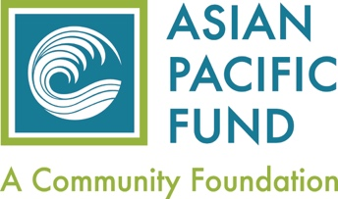

Affiliate Agency Application

Our mission is to strengthen the Asian and Pacific Islander community in the Bay Area by increasing philanthropy and supporting the organizations that serve our most vulnerable community members.

Agency Name (as appears in Articles of Incorporation/By Laws):

Agency Street Address, City and Zip Code:

Mailing Address (if different from above):

EIN:
Annual Operating Expense for last 3 years (please indicate FY or Calendar year):
2020:
2019:
2018:

Year Founded:

Telephone: ( )

Website:
Organization’s general e-mail address:

Name of Executive Director:

E-mail of Executive Director (for Asian Pacific Fund use only):

Organization Mission Statement:

List number of staff members:
Full Time ________ Part Time _________

Provide information below that demonstrates your staff has expertise, cultural competence and language ability to deliver services to vulnerable Asian and/or Pacific Islander community members:

How many clients are served annually by your organization? _____________

What percentage of your clients served are Asian and/or Pacific Islander? __________

List top 3 ethnicities of clients served [optional]

Brief description of key programs (three are adequate) administered (350 word limit), or attach agency brochure:

Location of Organizational Headquarters: _________________________

List Geographic Focus Area: (cities or counties) served by your organization:

Choose 1 or “maximum” 2 Service Categories listed below that best describes your organization:

___Empower Women ___Promote Health & Well-being
___Youth Development ___Support Families
___Support Seniors ___Foster Cultural Preservation/Arts
___Provide Legal Services ___Encourage Civic Engagement
___Assist New Immigrants ___Community Development
___Environmental Conservation ___Other______________________

**Please attach the following documents along with this completed application and email to joan@asianpacificfund.org:

1. List of Board of Directors (first/last name, ethnicity and affiliation /title)
2. Copy of 501(c)(3) tax exemption letter
3. Copy of most recently filed IRS Form 990 or audited financial statements

We have reviewed the “Affiliate Agency Guidelines,” as listed on your website and affirm that our organization meets the outlined criteria as well as all applicable federal, state, and local registration and reporting requirements for not-for-profit organizations. If accepted as an affiliate agency of the Fund, we agree to participate in the manner outlined in “Affiliate Agency Guidelines.”

Signature of the Executive Director: ________________________ Date: _______

Name of the President of the Board:

Signature of the President of the Board: _______________________ Date: _______

(revised Sep 2021)

