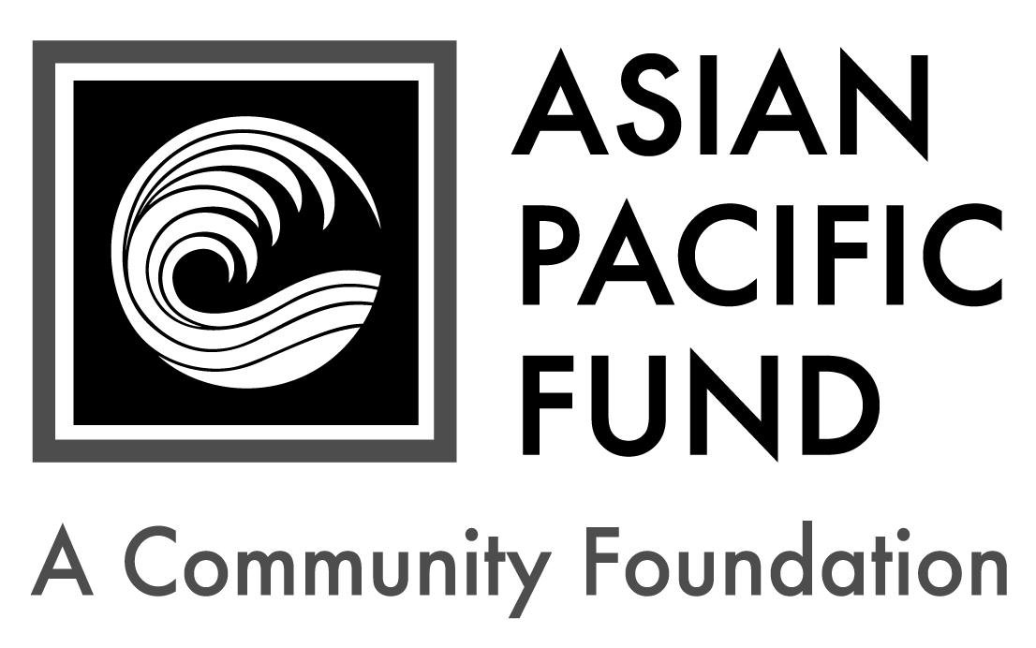
Chevron Filipino Employee Network Scholarship

Deadline: Friday, March 26, 2021
Background Information:
- Number of awards: 2 -3
- Amount: $2,000-$3,000
- Type: One-time award
Eligibility Criteria:
- Incoming freshman to be enrolled as a full-time student at an accredited four-year college or university in the Fall of 2021
- Be of Asian and/or Pacific Islander ethnicity as defined by the U.S. Census
- Engineering, computer, physical or environmental science majors
- Minimum GPA 2.80
- Financial need
- Resident of California, with preference for Bay Area, Southern California and Bakersfield area residents.

Selection Criteria:
- Academic achievement
- Potential to succeed, including time management skills and realistic goals
- Personal strengths, including responsibility, maturity, motivation and ability to overcome hardships
- Community service
- Financial need

Application Checklist: Applicants are responsible for submitting all materials to the Asian Pacific Fund by the deadline. Incomplete applications will not be evaluated. This application becomes complete and valid only when the Asian Pacific Fund has received all of the following materials:

Completed student application form
Essays
Most recent transcript(s) of grades (including grading scale); unofficial transcripts are OK
Resume (include work experience, school activities, community service, honors & awards)
Two letters of recommendation, at least one of which is from a current teacher
Letters should be on official school or organization letterhead. Please include the student’s first and last name.

Completed application form with supplemental materials must be postmarked and mailed by Friday, March 26, 2021 to:

Asian Pacific Fund
Chevron Filipino Employee Network Scholarship
465 California Street, Suite 809
San Francisco, CA 94104

Questions? Check our Frequently Asked Questions page or e-mail scholarship@asianpacificfund.org.

Scholarship Application

To apply, please complete the following application form. Please type or print legibly.

Contact and Household Information

First name: |  |  | Middle name/initial: |  | Last name:
Home phone:  ( ) - |  | Cell phone:  ( ) - |  |  |  |  | Date of birth: / /
Email address: |  |  |  | Gender:
Ethnic Heritage of…(not names)
Mother: | Maternal Grandmother: |  |  |  |  | Maternal Grandfather:
Father: | Paternal Grandmother: |  |  |  |  | Paternal Grandfather:

Permanent Residence
Address (Number & Street): |  |  |  | Apartment/Suite:
City: | State: | Zip Code: | County (not Country):

Mailing Address (if different from above)
Address (Number & Street): |  |  | Apartment/Suite:
City: | State: | Zip/Postal Code:

Parent or Guardian Information
First name: |  | Middle name/initial: |  | Last name:
Relation to applicant: | Telephone:  ( ) - |  | Email address:
Address (if different from above):

Will you be the first in your immediate family (parents and siblings) to attend and graduate from college? Yes No

Citizenship Status
Are you a citizen or permanent resident of the United States? Yes No

Publicity
How did you hear about this program? (please check all that apply)
College/Career Counselor Teacher Family/Family Friend
Internet (please specify): Other (please specify):

First & last name:

Financial Information
Parents’ Financial Data (to be completed if student is still in parents’ household or claimed as a dependent. Use data based on most recently filed tax form or “Your Parents’ Information” on most recent FAFSA form)
Adjusted Gross Income:  (Form 1040 – line 37) |  |  | Total Cash, Checking, Savings & Cash Value of Stocks:  (exclude retirement plan funds, IRA, 401K)
Total Income of Father: |  |  |  |  | Occupation of Father:
Total Income of Mother: |  |  |  |  | Occupation of Mother:
Parents’ Marital Status: |  | Married Divorced Separated Widowed Single
Amount of additional income: |  |  |  | Source(s): |  | Child Support Social Security  TANF Other:
Special Financial Circumstances:

Student’s Financial Data (to be completed if the student is employed part- or full-time)
Adjusted Gross Income:  (Form 1030 – line 37) |  |  | Total Cash, Checking, Savings & Cash Value of Stocks:  (exclude retirement plan funds, IRA, 401K)
Total Income: |  | Occupation: |  | Average hours worked per week:

Household Information: Some programs have a maximum household income requirement. Please see eligibility criteria for maximum household income to be considered for the scholarship.
Please provide your Estimated Family Contribution (EFC):
The EFC is located on the top-right of page 1 of the FAFSA Student Aid Report. If you are ineligible to apply for FAFSA, write "Not Applicable" in this field. If you have not completed your FAFSA, use the FAFSA4Caster to estimate your EFC.
Number of people in household supported by reported income:
Number of household members attending college in 2021-22:

Other Awards: List the name and annual amount of any grants/scholarships you have been awarded for 2021-22.
Name of Award: | School to which award will be applied: | Amount: | Status:
 |  | $ | Granted Pending
 |  | $ | Granted Pending
 |  | $ | Granted Pending

First & last name:

Academic Information

Academic Information
High School: |  |  | City:
Weighted GPA: |  | Unweighted GPA (4.0 scale):
Expected High School Graduation Date: Month / Year

Test Scores, if available: Please write “N/A” if you have not taken the tests below.
SAT Mathematics: |  | SAT Reading & Writing: |  |  | SAT Total Score:
SAT Subject Tests  (if taken): | Subject: |  | Score: | Subject: |  | Score:
 | Subject: |  | Score: | Subject: |  | Score:
ACT
Composite: English: Mathematics: Reading: Science:

College/University Information
Status of College Decisions:
 | School | City, State | Acceptance Status
 |  |  | Accepted | On waitlist |  | Awaiting reply
1st Choice
2nd Choice
3rd Choice

Intended major: | Expected College Graduation Date:  Month / Year
Housing plans for 2021-22: Commute from home Live on campus Live off campus
If attending a public college/university, will you be paying in-state tuition? Yes No

Essay Questions
Please respond to each of the short essay questions below on a separate sheet of paper. Your essays should be in 12-point font and single-spaced. At the top of the page, include your name and the name of the scholarship program. After each essay, please include the word count.

- Tell us about yourself, including your academic and career goals, hopes and dreams for the future. Recommended length: 250-500 words
- Describe your proudest moment and the greatest challenge you have faced, either personally or academically. What did you learn from these experiences? Recommended length: 150-200 words
- Describe an experience or person related to your academic and/or career goals that inspired you. What impact did it have on you? Recommended length: 150-200 words
- Optional: Is there anything else you would like us to know, including any unusual family or personal circumstances that have affected your achievement in school, work experience or your participation in school activities?

First & last name:

Complete & sign portion below:

I state under penalty of perjury that to the best of my knowledge all of the information provided in this application is true, and accurate. If selected as a recipient of the Chevron Filipino Employee Network scholarship, I agree to provide any additional documentation that may be required.

Student Signature: _______________________________ Date: _________
Print Student’s Name: ________________________

If student is under 18 years old:
Parent’s Signature: ________________________________ Date: _________
Print Parent’s Name: __________________________

