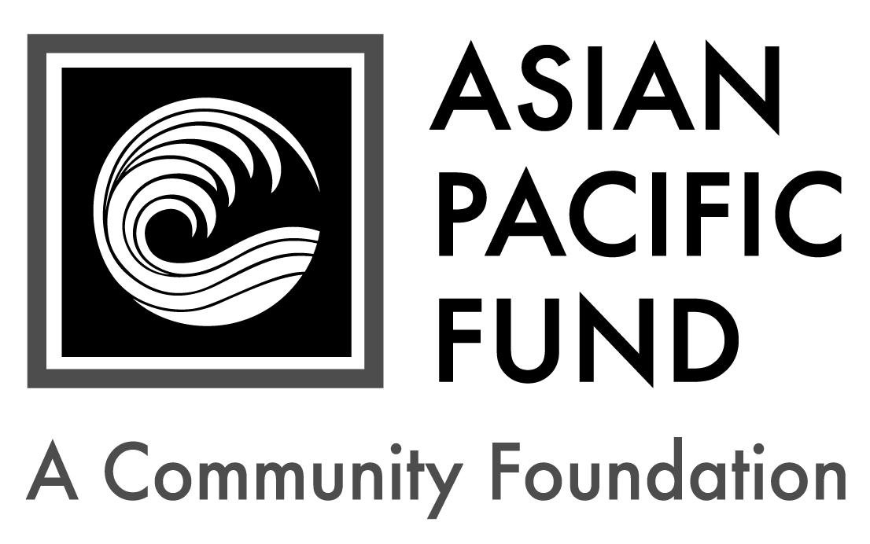
Matt Fong Asian Americans in
Public Finance Scholarship

Deadline: Friday, April 9, 2021
Eligibility Criteria:
- Grade level: Incoming sophomore, junior or senior at a four-year college or university in 2021-22
- Must be enrolled in California college or university
- Major: Accounting, political science, public policy, business administration, economics or related fields
- Ethnic heritage: Asian (at least 50%)
- Minimum GPA: 3.0
- Preference given to those with record of community service or volunteer work
Background Information:
- Number of awards: 2
- Amount: $2,500 - $5,000
- Renewable? no
- Established in memory of Matt Fong

Selection Criteria:
- Academic achievement
- Potential to succeed
- Volunteer service

Purpose: Asian Americans in Public Finance strives to enhance, develop and promote the professional lives and careers of dedicated Asian Americans in public finance as well as those interested in pursuing a career in public finance or the public sector. Public Finance is the study of government’s impact on the economy, and a profession in public finance involves the funding and financial management of public goods, services, and facilities provided directly by state and local governments, through its agencies or community not-for-profit organizations. A profession in this field requires a commitment to public service.

The Matt Fong Asian Americans in Public Finance scholarship honors the memory of former California state treasurer, Matt Fong, for his dedication to public service, active involvement in state politics, and direct impact he had in opening up opportunities for Asian Americans in the public finance industry. Matt Fong’s life embodied the mission of the Asian Americans in Public Finance organization.

Application Checklist: Applicants are responsible for submitting all materials to the Asian Pacific Fund by the deadline. Incomplete applications will not be evaluated. This application becomes complete and valid only when the Asian Pacific Fund has received all of the following materials:

Completed student application form
Essays
Most recent transcript(s) of grades (including grading scale); unofficial transcripts are OK
Resume (include work experience, school activities, community service, honors & awards)
Two letters of recommendation, at least one of which is from a current professor
Letters should be on official school or organization letterhead. Please include the student’s first and last name.

Note: Six to 10 finalists will be chosen. If chosen, finalists must submit official transcript(s) of grades and FAFSA student aid report.

Completed application form with supplemental materials must be postmarked by Friday, April 9, 2021. Please send to:

Matt Fong Asian Americans in Public Finance Scholarship
Asian Pacific Fund
465 California Street, Suite 809
San Francisco, CA 94104

Questions? Check our Frequently Asked Questions page or e-mail scholarship@asianpacificfund.org.

Scholarship Application
To apply, please complete the following application form. Please type or print legibly.

Contact and Household Information
Personal Information
First name: |  |  | Middle name/initial: |  | Last name:
Home phone:  ( ) - |  | Cell phone:  ( ) - |  |  |  |  | Date of birth: / /
Email address: |  |  |  | Gender:
Ethnic Heritage of…
Mother: | Maternal Grandmother: |  |  |  |  | Maternal Grandfather:
Father: | Paternal Grandmother: |  |  |  |  | Paternal Grandfather:

Permanent Residence
Address (Number & Street): |  |  |  | Apartment/Suite:
City: | State: | Zip/Postal Code: | County:

Mailing Address (if different from above)
Address (Number & Street): |  |  | Apartment/Suite:
City: | State: | Zip/Postal Code:

Parent or Guardian Information
First name: |  | Middle name/initial: |  | Last name:
Relation to applicant: | Telephone:  ( ) - |  | Email address:
Address (if different from above):

Household Information: Some programs have a maximum household income requirement. Please see eligibility criteria for maximum household income to be considered for the scholarship.
Annual Household Income (please check one):
< $20,000 $20,000 - 39,999 $40,000 - 59,999
$60,000 - 79,999 $80,000 - 99,999 $100,000+ (actual: )
Please provide your Estimated Family Contribution (EFC):
The EFC is located on the top-right of page 1 of the FAFSA Student Aid Report. If you are ineligible to apply for FAFSA, write "Not Applicable" in this field. If you have not completed your FAFSA, use the FAFSA4Caster to estimate your EFC.
Number of people in household supported by reported income:
Number of household members attending college in 2021-22:

Publicity
How did you hear about this program? (please check all that apply)
College/Career Counselor Teacher Family/Family Friend
Internet (please specify): Other (please specify):

First & last name:
Financial Information

Parents’ Financial Data (to be completed if student is still in parents’ household or claimed as a dependent. Use data based on most recently filed tax form or “Your Parents’ Information” on most recent FAFSA form)
Adjusted Gross Income:  (Form 1040 – line 37) |  |  | Total Cash, Checking, Savings & Cash Value of Stocks:  (exclude retirement plan funds, IRA, 401K)
Total Income of Father: |  |  |  |  | Occupation of Father:
Total Income of Mother: |  |  |  |  | Occupation of Mother:
Marital Status of Parent(s)/Guardian(s): |  | Married Divorced Separated  Widowed Single
Amount of additional income: |  |  |  | Source(s): |  | Child Support Social Security  TANF Other:
Special Financial Circumstances:

Student’s Financial Data (to be completed if the student is employed part- or full-time)
Adjusted Gross Income:  (Form 1030 – line 37) |  |  |  | Total Cash, Checking, Savings & Cash Value of Stocks:  (exclude retirement plan funds, IRA, 401K)
Total Income: |  | Occupation: |  |  |  |  | Average hours worked per week:
Number of your dependents: |  |  | Your dependent status: |  |  | Living with parent(s); claimed as dependent  Financially independent from parent(s)
Your Marital Status: |  | Married Divorced Separated  Widowed Single
Amount of additional income: |  |  |  |  | Source(s): |  |  | Child Support Social Security  TANF Other:

Other Awards: List the name and annual amount of any grants/scholarships you have been awarded for 2021-22.
Name of Award: | School to which award will be applied: | Amount: | Status:
 |  | $ | Granted Pending
 |  | $ | Granted Pending
 |  | $ | Granted Pending

First & last name:
Academic and Career Information

Academic Information:
College/University: |  |  | Year in school (Fall 2021):
Major: | Expected College Graduation Date: Month / Year
College cumulative GPA: |  | College term GPA (Fall 2020):

Other College Information:
Housing plans for 2021-22: Commute from home Live on campus Live off campus
If attending a public college/university, will you be paying in-state tuition? Yes No

Essay Questions
Please respond to each of the short essay questions below on a separate sheet of paper. Your essays should be in 12-point font and single-spaced. At the top of the page, include your name and the name of the scholarship program. After each essay, please include the word count.

- Tell us about yourself, including your academic and career goals, hopes and dreams for the future and the role/influence of your Asian heritage. Recommended length: 250-500 words
- Describe your proudest moment and the greatest challenge you have faced, either personally or academically. What did you learn from these experiences? Recommended length: 150-200 words
- What is your field of study or major? What interests you about this field? Does a career in public finance interest you? How might your field of study prepare you for a career in public finance? Recommended length: 250-500 words
- Describe any community service or volunteer work you have done in the community. How do you envision giving back to the community in the future? Recommended length: 150-200 words
- Optional: Is there anything else you would like us to know, including any unusual family or personal circumstances that have affected your achievement in school, work experience or your participation in school activities?

Complete & sign portion below:

I state under penalty of perjury that to the best of my knowledge all of the information provided in this application is true, and accurate. If selected as a recipient of the Matt Fong Asian Americans in Public Finance Scholarship, I agree to provide any additional documentation that may be required.

Student Signature: _______________________________ Date: _________
Print Student’s Name: ________________________

If student is under 18 years old:
Parent’s Signature: ________________________________ Date: _________
Print Parent’s Name: __________________________

