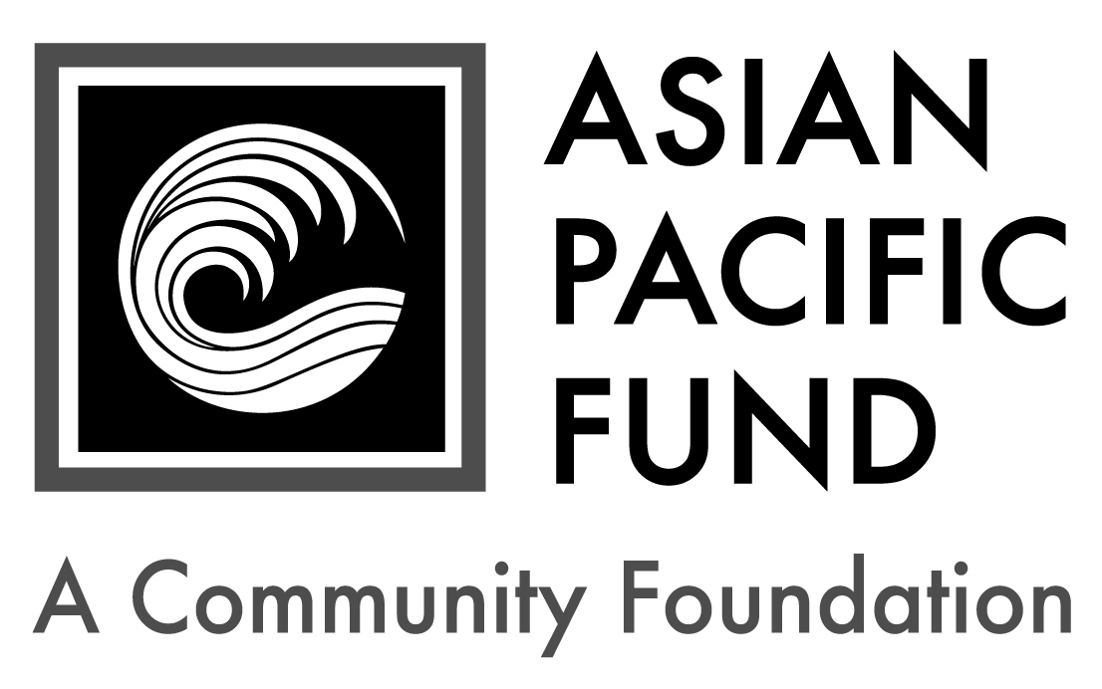
Tina E. Yeh
Community Service Fellowship

FELLOWSHIP APPLICATION
Deadline: Friday, March 18, 2016
Eligibility Criteria:

Yale undergraduate (preference given), recent graduate, or graduate student

Asian ethnic heritage

Demonstrated financial need

Background Information:

$3,000 fellowship grant

10-week internship at a non-profit organization that serves the Asian American community

Purpose: The Asian American community is the fastest growing and most diverse segment of the U.S. population, but Asian needs and concerns are often overlooked or completely hidden from view. The Tina E. Yeh Community Service Fellowship offers students and recent graduates an opportunity to learn about and directly contribute to the Asian community. The fellowship is awarded to students doing direct service in the Asian American or Asian Canadian community in Northern America.

Who is Tina E. Yeh?

Tina Eugenia Yeh graduated from Yale University in 1983 and received a master's degree at Yale's School of Organization and Management. She was a dedicated ethnic counselor at Yale and stayed in touch with her counselees for many years. Tina was a gentle and kind soul and touched lives with her grace, selflessness and good humor. Tragically, Tina, her father and aunt died in the Singapore Airlines crash in Taipei in October 2000. In 2001, the family and friends of Tina Yeh established a fund in her memory. Their efforts made the fellowship program a permanent resource for Yale students and for Asian community-based groups.

Founders: The Association of Asian American Yale Alumni (AAAYA) is an all-volunteer group that established the Tina E. Yeh Community Service Fellowship through the Asian Pacific Fund, a community foundation, in honor of Tina E. Yeh ‘83. The fellowship program encourages Yale undergraduates and recent graduates to become involved in community service through summer internships. Inspired by Tina Yeh’s generosity of time and spirit as an ethnic counselor, the fellowship supports students who want to be involved in the Asian American community and encourages Asian Yale graduates to stay connected as volunteers, staff, board members and donors. For more information on AAAYA and the Asian Pacific Fund, please visit www.aaaya.org and www.asianpacificfund.org.

Application Parts:
- Completed application form;
- Two short essay questions (250-500 words each);
- Letter of sponsorship from host organization and project description; and
- Unofficial transcript and FAFSA student aid report.

Completed application form with supplemental materials must be received or emailed by 11:59 p.m. EST, Friday, March 18, 2016. Please send to:

scholarship@asianpacificfund.org OR Tina E. Yeh Community Service Fellowship
Asian Pacific Fund
465 California Street, Suite 809
San Francisco, CA 94104

Questions? Contact Scholarship Manager Sue May by phone 415-395-9985 x300 or by email scholarship@asianpacificfund.org.

Tina E. Yeh
Community Service Fellowship

FELLOWSHIP APPLICATION FORM
Personal Information
First name: |  |  |  | Middle name/initial: |  |  | Last name:
Home phone: |  |  | Cell phone: |  |  |  |  |  | Date of birth: / /
Email address: |  |  |  |  |  | Gender: Female Male
Asian* Heritage of… (please check all that apply and specify ethnicity):
Mother: |  | Maternal Grandmother: |  |  |  |  |  | Maternal Grandfather:
Father: |  | Paternal Grandmother: |  |  |  |  |  | Paternal Grandfather:
How did you hear about this program? (please check all that apply)
Professor | Family/ Friend |  | Info session |  | Internet: (specify website) |  |  |  |  | Other:

Selected Host Organization
Organization: | Location: | Website:
Supervisor Name: | Email: | Phone:

Permanent Residence
Address (Number & Street): |  |  | Apartment/Suite:
City: | State: | Zip/Postal Code:

Mailing Address (if different from above)
Address (Number & Street): |  |  | Apartment/Suite:
City: | State: | Zip/Postal Code:

Parent or Guardian Information
First name: |  | Middle name/initial: |  | Last name:
Relation to applicant: | Telephone: |  | Email address:
Address (if different from above):

Academic/Financial Information
Status: Undergrad Recent Grad Graduate Student |  |  | Residential college:
Class of: | Cumulative GPA: | Do you receive financial aid? Yes No
Annual Household Income (please check one):
< $20,000 $20,000 - 39,999 $40,000 - 59,999
$60,000 - 79,999 $80,000 - 99,999 $100,000+ (actual: )

Essay Questions

Please respond to each of the short essay questions below on a separate sheet of paper. Your essays should be in 12-point font and single-spaced. Include your name and the name of the fellowship program (“Tina E. Yeh Community Service Fellowship”) at the top of each page. Recommended length for each essay is 250-500 words.

- What do you hope to learn or gain from your internship? How will this internship enrich your personal or professional goals?

- Tell us a little about yourself. What experiences (or individuals) have influenced you and your outlook in life? Please use this opportunity to demonstrate to us how and why you would be an appropriate candidate for the Tina E. Yeh Community Service Fellowship.

Host Organization Selection & Project Description

An applicant should plan to serve as an intern at a host organization. Applicants may contact an organization from the suggested list OR identify their own host organization and project. In either case, applicants MUST obtain a letter of sponsorship from the host organization (see sample sponsorship letter on page 6). The fellowship will be paid for by a $3,000 grant to the host organization, which will use the grant to pay the intern a stipend.

After agreeing on a project and terms for the internship please work with the host organization to complete a project description. See below for project description guidelines. Suggested projects include: assisting with research, organization or publicity/outreach, organizing community events, working on interagency committees, assisting with seasonal projects or updating the organization’s website

Suggested List of Host Organizations
Agency Name | Location | Website
Angel Island Immigration Station Foundation | San Francisco, CA | www.aiisf.org
Asian American Federation | New York, NY | www.aafederation.org
Asian Americans for Community Involvement | San Jose, CA | www.aaci.org
Asian American Justice Center | Washington, DC | www.advancingequality.org
Asian Law Caucus | San Francisco, CA | www.asianlawcaucus.org
Center for Asian American Media | San Francisco, CA | www.caamedia.org
Chinatown Progressive Association | Boston, MA | www.cpaboston.org
Chinese American Planning Council | New York, NY | www.cpc-nyc.org
Coalition for Asian American Children and Families | New York, NY | www.cacf.org
Vietnamese Community of Orange County | Orange County, CA | www.thevncoc.org
For direct contact information, please contact the Asian Pacific Fund at scholarship@asianpacificfund.org.

Project Description: The project description may be completed by the student or the host organization. Please include the following in the project description, including:
- Project name
- Purpose of project and how it will support the mission of the host organization
- How progress will be measured
- Student's tasks
- If you're planning to work on a community service project of your own design, please submit a project proposal that has been approved by your host organization.Project proposals should include:
  - the project’s goal
  - who will be involved, if anyone besides the student
  - student’s specific skills or educational background that make him/her qualified to do the project
  - kind of supervision or mentoring expected from the host organization
  - the project's benefit to the host organization
  - any costs that the organization would incur to host the project

Letter Of Sponsorship From Host Organization:

- Confirmation letter must:
  - be on organization letter head and signed by the Executive Director
  - confirm that applicant and host organization have agreed on the nature and scope of the internship project
  - confirm that host organization is willing and ready to host the internship during specified time period
  - confirm that applicant has committed to accept internship with the host organization if awarded a fellowship

- If the student is selected for the fellowship, the host organization must provide:
  - Copy of the organization’s IRS letter of determination (confirming tax-exempt status)
  - Link to brief description of the organization, including services and programs offered OR a copy of the organization’s annual report
  - Name, title, phone number and e-mail address of the intern’s direct supervisor

Complete & Sign portion below:

I state under penalty of perjury that to the best of my knowledge all of the information provided in this application is true, and accurate. If selected as a recipient of the Tina E. Yeh Community Service Fellowship, I agree to provide any additional documentation that may be required.

Student’s printed name:
Student’s signature: Date:

If student is under the age of 18:
Parent’s printed name:
Parent’s signature: Date:

Resources and Sample Documents

Resources to locate an Asian organization:
National: www.AdvancingEquality.org/communitypartnersroster (more than 90 Asian organizations, in 48 cities in 25 states)
Metropolitan Chicago area: www.aaichicago.org (21 Asian community organizations)
Metropolitan New York City and New Jersey: www.aafny.org (online directory of 145 Asian human service agencies)
San Francisco Bay Area: www.asianpacificfund.org (94 Asian affiliate organization listings)
Southern California: www.ocapica.org (more than 40 Asian resources); www.a3pcon.org (more than 35 Asian member organizations); www.apalc.org (links to other Asian organizations and resources)

Sample follow-up letters for students to send to host organization:
I am applying for a fellowship available to Yale Asian undergraduate students that will enable me to work while being fully paid for by a $3,000 grant to your organization with the understanding that you would use the grant funds to pay me a stipend. The requirement is that we have a mutually agreed upon scope of work.
The fellowship can be for at least 10 weeks, and I am available from (month/day) to (month/day). Currently, I am a (year) at Yale and studying/majoring in (area). I expect to pursue a career in one of the following fields: ___________________.

My prior work experience and work-study assignments which might be relevant for your organization include: _____________. My technical skills include: (list software). My language skills are: ______________________. In thinking about possible projects for this assignment, I should also add that I especially like: ______________________ (e.g. working with people, doing research, I'm a strong writer, etc.).

I am applying for a fellowship available to Yale Asian undergraduate students that will enable me to work while being fully paid for by a $3,000 grant to your organization with the understanding that you would use the grant funds to pay me a stipend. The requirement is that we have a mutually agreed upon scope of work.
I would like to work with your organization on (project name/description) and (how it will benefit organization). This fellowship program allows the student to design a project, provided that the project is hosted by a non-profit organization that serves Asian Americans. I hope your organization will consider hosting my project because (describe the connection between your project and the mission of the organization as described on the organization website).

I have included a project proposal for your review.

Project proposal: 1) goal, 2) who will be involved, if anyone besides you, 3) your specific skills or educational background that make you qualified to do this project, 4) what kind of supervision or mentoring you would like to have from the host organization, 5) any costs that the organization would incur to host your project, 6) the project’s benefit to the host organization

Sample Confirmation Letter from Sponsoring Organization

Letter must be on organization letterhead and signed by the Executive Director. Please see the suggested language for the Executive Director of the host organization:
This is to confirm that, if awarded a fellowship, (Intern Name) will be a summer intern at (Sponsoring Organization) from (start date – mm/dd) to (end date – mm/dd).
As the host organization, we agree to accept the Tina E. Yeh Community Service Fellowship grant from the Asian Pacific Fund to support (Intern Name) ‘s work as described in his/her project description/proposal, which I have reviewed and approved.

The intern's direct supervisor, (Name of Supervisor) , will submit a brief report on the intern's work/project at the end of the summer.

Signed by: _____________________________ Date:________________ Executive Director

* Asian includes: Chinese, Filipino, Indian, Japanese, Korean, Vietnamese, South Asian, Southeast Asian, Pacific Islander and other Asian.

