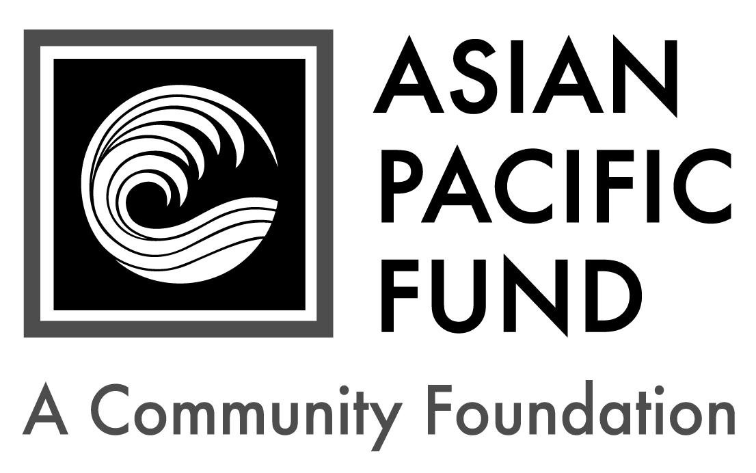
Shui Kuen and Allen Chin Scholarship

Postmark Deadline: Monday, March 2, 2020
Eligibility Criteria:
- Grade level: Incoming freshman or current, full-time undergraduate at a 2-year community college or 4-year college/university in 2020-21
- Self or parent currently or formerly employed at an Asian-owned or Asian cuisine restaurant
- Community advocacy and social justice work on behalf of Asian American, immigrant, gay and lesbian and/or other progressive causes
- Minimum GPA: 3.0
- Financial need
- Open to all ethnicities

Background Information:
- Number of awards: up to 2
- Amount: $1,000
- Renewable? No

Selection Criteria:
- Personal strengths, including overcoming hardships & understanding restaurant worker environment
- Academic achievement
- Potential to succeed, including time management skills & challenging goals
- Community service, including involvement in the Asian American community & other progressive causes

Application Checklist: Applicants are responsible for submitting all materials to the Asian Pacific Fund by the deadline. Incomplete applications will not be evaluated. This application becomes complete and valid only when the Asian Pacific Fund has received all of the following materials:

Completed student application form
Essays
Most recent transcript(s) of grades (including grading scale); unofficial transcripts are OK
Resume (include work experience, school activities, community service, honors & awards)
Two letters of recommendation, at least one of which is from a current teacher or professor
Letters should be on official school or organization letterhead. Please include the student’s first and last name.

Note: Five to 10 finalists will be chosen. If chosen, finalists must submit official transcript(s) of grades, SAT/ACT score reports and FAFSA student aid report.

Completed application form with supplemental materials must be postmarked by Monday,
March 2, 2020. Please mail to:

Shui Kuen and Allen Chin Scholarship
Asian Pacific Fund
465 California Street, Suite 809
San Francisco, CA 94104

Questions? Check our Frequently Asked Questions page or e-mail scholarship@asianpacificfund.org.

Scholarship Application

To apply, please complete the following application form. Please type or print legibly.

Contact and Household Information
Personal Information
First name: |  |  | Middle name/initial: |  | Last name:
Home phone:  ( ) - |  | Cell phone:  ( ) - |  |  |  |  | Date of birth: / /
Email address: |  |  |  | Gender:
Ethnic Heritage of…(not names)
Mother: | Maternal Grandmother: |  |  |  |  | Maternal Grandfather:
Father: | Paternal Grandmother: |  |  |  |  | Paternal Grandfather:

Permanent Residence
Address (Number & Street): |  |  |  | Apartment/Suite:
City: | State: | Zip Code: | County (not Country):

Mailing Address (if different from above)
Address (Number & Street): |  |  | Apartment/Suite:
City: | State: | Zip/Postal Code:

Parent or Guardian Information
First name: |  | Middle name/initial: |  | Last name:
Relation to applicant: | Telephone:  ( ) - |  | Email address:
Address (if different from above):

Will you be the first in your immediate family (parents and siblings) to attend college? Yes No

Publicity
How did you hear about this program? (please check all that apply)
College/Career Counselor Teacher Family/Family Friend
Internet (please specify): Other (please specify):
First & last name:
Financial Information
Parents’ Financial Data (to be completed if student is still in parents’ household or claimed as a dependent. Use data based on most recently filed tax form or “Your Parents’ Information” on most recent FAFSA form)
Adjusted Gross Income:  (Form 1040 – line 37) |  |  | Total Cash, Checking, Savings & Cash Value of Stocks:  (exclude retirement plan funds, IRA, 401K)
Total Income of Father: |  |  |  |  | Occupation of Father:
Total Income of Mother: |  |  |  |  | Occupation of Mother:
Parents’ Marital Status: |  | Married Divorced Separated Widowed Single
Amount of additional income: |  |  |  | Source(s): |  | Child Support Social Security  TANF Other:
Special Financial Circumstances:

Student’s Financial Data (to be completed if the student is employed part- or full-time)
Adjusted Gross Income:  (Form 1030 – line 37) |  |  |  | Total Cash, Checking, Savings & Cash Value of Stocks:  (exclude retirement plan funds, IRA, 401K)
Total Income: |  | Occupation: |  |  |  |  | Average hours worked per week:
Number of your dependents: |  |  | Your dependent status: |  |  | Living with parent(s); claimed as dependent  Financially independent from parent(s)
Your Marital Status: |  | Married Divorced Separated Widowed Single
Amount of additional income: |  |  |  |  | Source(s): |  |  | Child Support Social Security  TANF Other:

Household Information: Some programs have a maximum household income requirement. Please see eligibility criteria for maximum household income to be considered for the scholarship.
Please provide your Estimated Family Contribution (EFC):
The EFC is located on the top-right of page 1 of the FAFSA Student Aid Report. If you are ineligible to apply for FAFSA, write "Not Applicable" in this field. If you have not completed your FAFSA, use the FAFSA4Caster to estimate your EFC.
Number of people in household supported by reported income:
Number of household members attending college in 2020-21:

Other Awards: List the name and annual amount of any grants/scholarships you have been awarded for 2020-21.
Name of Award: | School to which award will be applied: | Amount: | Status:
 |  | $ | Granted Pending
 |  | $ | Granted Pending
 |  | $ | Granted Pending
First & last name:
Academic and Career Information

Academic Information: Please write “N/A” if it does not apply to you.
High School: |  |  |  |  |  | City:
H.S. Weighted GPA: |  |  | H.S. Unweighted GPA (4.0 scale):
Expected High School Graduation Date: Month / Year
For current college students:  College/University: |  |  |  |  | Year in school (Fall 2020):
Major: |  | Expected College Graduation Date: Month / Year
College cumulative GPA: |  |  |  | College term GPA (Fall 2019):

Other College Information:
Housing plans for 2020-21: Commute from home Live on campus Live off campus
If attending a public college/university, will you be paying in-state tuition? Yes No

Test Scores: For incoming freshmen only. Please write “N/A” if you have not taken the tests below.
SAT Math: |  | SAT Reading & Writing: |  |  | SAT Total score:
SAT Subject Tests  (if taken): | Subject: |  | Score: | Subject: |  | Score:
 | Subject: |  | Score: | Subject: |  | Score:
ACT
Composite: English: Mathematics: Reading: Science:

Restaurant Worker Information
Name of Restaurant Worker: |  |  | Relation to applicant:
Name of Restaurant: |  | City: |  |  | State:
Period of Employment: | Start (mm/yy): |  |  | End (mm/yy):

Essay Questions
Please respond to each of the short essay questions below on a separate sheet of paper. Your essays should be in 12-point font and single-spaced. At the top of the page, include your name and the name of the scholarship program. After each essay, please include the word count.
- Tell us about yourself, including your academic and career goals, hopes and dreams for the future and your proudest moment of your personal or academic life. Recommended length: 250-500 words
- Describe your experience as a restaurant worker or child of a restaurant worker. What have you learned from the experience? How has it shaped your values? Recommended length: 250-500 words
- Describe any community service or school project you have done in the mainstream or Asian American community that has shaped your ideas about the Asian American community. How do you envision giving back to the community in the future? Recommended length: 250-500 words
- Optional: Is there anything else you would like us to know, including any unusual family or personal circumstances that have affected your achievement in school, work experience or your participation in school activities?

Complete & sign portion below:
I state that all of the information provided in this application is true, and, if selected as a recipient of the Shui Kuen and Allen Chin Scholarship, I agree to provide additional documentation that is required.

I also acknowledge that Curtis Chin and the Chin family members are the Benefactors of the Shui Kuen and Allen Chin Scholarship. I affirm under penalty of perjury that I, (print student name) , am not related to the Benefactors in any of the following ways: household member, family member (brother, sister, uncle, aunt, grandparent, or first cousin, or any of the listed relationships by marriage), and descendant (child or grand-child whether or not they are household members).

Furthermore, I affirm under penalty of perjury that no one in my family or household, including myself, is an employee of the Benefactors or, to the best of my knowledge, an employee of a company in which the Benefactors hold controlling interest.

Student Signature: _______________________________ Date: _________
Print Student’s Name: ________________________

If student is under 18 years old:
Parent’s Signature: ________________________________ Date: _________
Print Parent’s Name: __________________________

