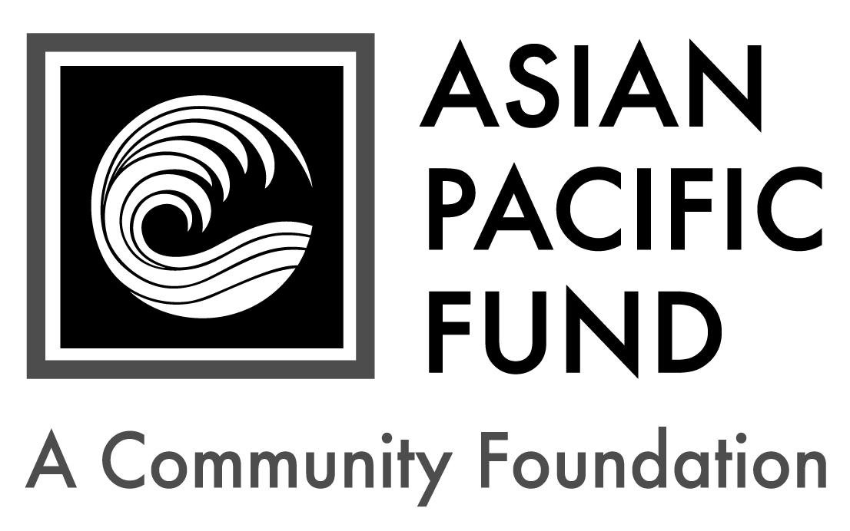
Helen and L.S. Wong Memorial Scholarship

PLEASE NOTE: This scholarship is not the same award offered through Assist-A-Grad. Please fill out separate applications.

Postmark Deadline: Friday, February 23, 2018
Eligibility Criteria:
- Resident of or graduating high school senior from a high school in Fairfield or Suisun City, CA
- Incoming freshman enrolled full-time at an accredited four year-college/university or community college (with strong commitment to transfer to a four-year institution) in 2018-19
- Ethnic heritage: Asian heritage (at least 50%)
- Minimum 2.8 GPA
- Financial need
- U.S. citizen or permanent resident

Background Information:
- Number of awards: 1 - 4
- Amount: $1,000-3,000
- Renewable? Yes, for $500-1,000
- Total award: $2,500-6,000

Selection Criteria:
- Academic achievement
- Personal and career focus
- Personal strengths, including maturity, motivation and potential to succeed

Application Checklist: Applicants are responsible for submitting all materials to the Asian Pacific Fund by the deadline. Incomplete applications will not be evaluated. This application becomes complete and valid only when the Asian Pacific Fund has received all of the following materials:

Completed student application form
Essays
Most recent transcript(s) of grades (including grading scale); unofficial transcripts are OK
Resume (include work experience, school activities, community service, honors & awards)
Two letters of recommendation, at least one of which is from a current teacher
Letters should be on official school or organization letterhead. Please include the student’s first and last name.

Note: 10 to 15 finalists will be chosen. If chosen, finalists must submit official transcript(s) of grades, SAT/ACT score reports and FAFSA student aid report.

Completed application form with supplemental materials must be postmarked by Friday, February 23, 2018. Please send to:

Helen and L.S. Wong Memorial Scholarship
Asian Pacific Fund
465 California Street, Suite 809
San Francisco, CA 94104

Questions? Check our Frequently Asked Questions page or e-mail scholarship@asianpacificfund.org.
Scholarship Application
To apply, please complete the following application form. Please type or print legibly.

Contact and Household Information
Personal Information
First name: |  |  | Middle name/initial: |  | Last name:
Home phone:  ( ) - |  | Cell phone:  ( ) - |  |  |  |  | Date of birth: / /
Email address: |  |  |  | Gender:  Female Male
Ethnic Heritage of…(not names)
Mother: | Maternal Grandmother: |  |  |  |  | Maternal Grandfather:
Father: | Paternal Grandmother: |  |  |  |  | Paternal Grandfather:

Permanent Residence
Address (Number & Street): |  |  |  | Apartment/Suite:
City: | State: | Zip Code: | County (not Country):

Mailing Address (if different from above)
Address (Number & Street): |  |  | Apartment/Suite:
City: | State: | Zip/Postal Code:

Parent or Guardian Information
First name: |  | Middle name/initial: |  | Last name:
Relation to applicant: | Telephone:  ( ) - |  | Email address:
Address (if different from above):

Publicity
How did you hear about this program? (please check all that apply)
College/Career Counselor Teacher Family/Family Friend
Internet (please specify): Other (please specify):

Citizenship Status
Are you a citizen or permanent resident of the United States? Yes No
First & last name:
Financial Information

Parents’ Financial Data (to be completed if student is still in parents’ household or claimed as a dependent. Use data based on most recently filed tax form or “Your Parents’ Information” on most recent FAFSA form)
Adjusted Gross Income:  (Form 1040 – line 37) |  |  | Total Cash, Checking, Savings & Cash Value of Stocks:  (exclude retirement plan funds, IRA, 401K)
Total Income of Father: |  |  |  |  | Occupation of Father:
Total Income of Mother: |  |  |  |  | Occupation of Mother:
Marital Status of Parent(s)/Guardian(s): |  | Married Divorced Separated  Widowed Single
Amount of additional income: |  |  |  | Source(s): |  | Child Support Social Security  TANF Other:
Special Financial Circumstances:

Student’s Financial Data (to be completed if the student is employed part- or full-time)
Adjusted Gross Income:  (Form 1030 – line 37) |  |  | Total Cash, Checking, Savings & Cash Value of Stocks:  (exclude retirement plan funds, IRA, 401K)
Total Income: |  | Occupation: |  | Average hours worked per week:

Household Information: Some programs have a maximum household income requirement. Please see eligibility criteria for maximum household income to be considered for the scholarship.
Please provide your Estimated Family Contribution (EFC):
The EFC is located on the top-right of page 1 of the FAFSA Student Aid Report. If you are ineligible to apply for FAFSA, write "Not Applicable" in this field. If you have not completed your FAFSA, use the FAFSA4Caster to estimate your EFC.
Number of people in household supported by reported income:
Number of household members attending college in 2018-19:

Other Awards: List the name and annual amount of any grants/scholarships you have been awarded for 2018-19:
Name of Award: | School to which award will be applied: | Amount: | Status:
 |  | $ | Granted Pending
 |  | $ | Granted Pending
 |  | $ | Granted Pending

First & last name:
Academic and Career Information

Academic Information
High School: |  |  | City:
Weighted GPA: |  | Unweighted GPA (4.0 scale):
Expected High School Graduation Date: Month / Year

Test Scores: Please write “N/A” if you have not taken the tests below.
SAT Math: |  | SAT Reading & Writing: |  |  | SAT Total Score:
SAT Subject Tests  (if taken): | Subject: |  | Score: | Subject: |  | Score:
 | Subject: |  | Score: | Subject: |  | Score:
ACT
Composite: English: Mathematics: Reading: Science:

College/University Information
Status of College Decisions:
 | School | City, State | Acceptance Status
 |  |  | Accepted | On waitlist |  | Awaiting reply
1st Choice
2nd Choice
3rd Choice

Other College Information:
Intended major: | Expected College Graduation Date:  Month / Year
Housing plans for 2018-19: Commute from home Live on campus Live off campus
If attending a public college/university, will you be paying in-state tuition? Yes No

Essay Questions
Please respond to each of the short essay questions below on a separate sheet of paper. Your essays should be in 12-point font and single-spaced. At the top of the page, include your name and the name of the scholarship program. After each essay, please include the word count.

- Tell us about yourself, including your academic and career goals, hopes and dreams for the future and the role/influence of your Asian heritage. Recommended length: 250-500 words
- Describe your proudest moment and the greatest challenge you have faced, either personally or academically. What did you learn from these experiences? Recommended length: 150-200 words
- Describe a project, experience or person related to your academic and/or career goals that inspired you. What impact did it have on you? Recommended length: 150-200 words
- Optional: Is there anything else you would like us to know, including any unusual family or personal circumstances that have affected your achievement in school, work experience or your participation in school activities?

