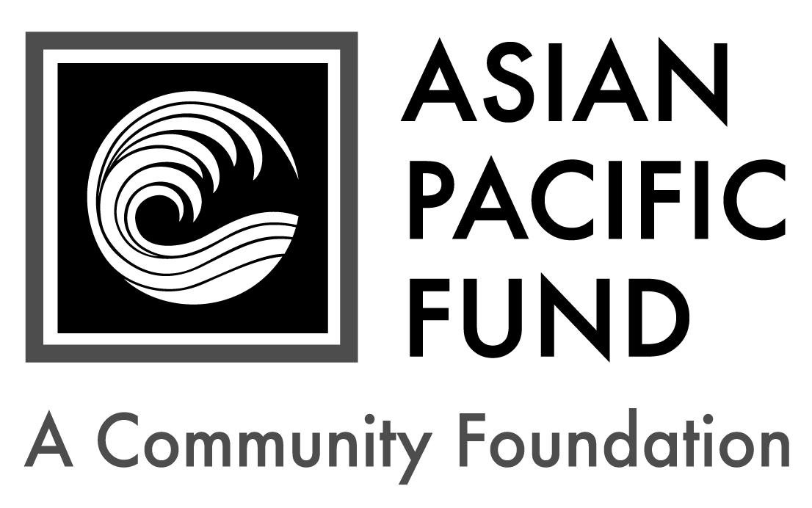
Maria Elena Yuchengco Memorial Journalism Scholarship

Postmark Deadline: Extended -Monday, May 16, 2016
Eligibility Criteria:
- Grade level: Incoming freshman or current, full-time undergraduate at a four-year college or university in 2016-17
- Major and/or Career Goal: Journalism
- Ethnic heritage: Filipino (at least 50%)
- Minimum GPA: 3.0
- Financial need
- San Francisco Bay Area resident
- US citizen or permanent resident
Background Information:
- Number of awards: 1 - 3
- Award up to: $3,000 total
- Renewable? Possible
- Established in memory of Maria Elena Yuchengco

Selection Criteria:
- Academic achievement
- Potential to succeed
- Financial need
- Involvement/interest in serving the Filipino community

Purpose: The public depends on news that is investigated, researched and reported by dedicated professionals. Good journalism requires talent, drive and a genuine interest in understanding the “total picture” and what is most important. Diversity among journalists plays a crucial role ensuring comprehensive and balanced presentation of the news. Because Filipinos are underrepresented in journalism, Mona Lisa Yuchengco, the founding publisher and editor of Filipinas Magazine, established this scholarship program to support students of Filipino heritage pursuing careers in journalism.

Application Checklist: Applicants are responsible for submitting all materials to the Asian Pacific Fund by the deadline. Incomplete applications will not be evaluated. This application becomes complete and valid only when the Asian Pacific Fund has received all of the following materials:

Completed student application form
Essays
Most recent transcript(s) of grades (including grading scale); unofficial transcripts are OK
Resume (include work experience, school activities, community service, honors & awards)
Two letters of recommendation, at least one of which is from a current teacher or professor
Letters should be on official school or organization letterhead. Please include the student’s first and last name.
Writing sample (journalism work preferred)

Note: Three to 10 finalists will be chosen. Finalists must be available for a 30-minute interview in late April in the San Francisco Bay Area (dates TBD). If chosen, finalists must submit official transcript(s) of grades, SAT/ACT score reports and FAFSA student aid report.

Completed application form with supplemental materials must be postmarked by Monday, May 16, 2016. Please send to:

Maria Elena Yuchengco Memorial Journalism Scholarship
Asian Pacific Fund
465 California Street, Suite 809
San Francisco, CA 94104

Questions? Check our Frequently Asked Questions page or e-mail scholarship@asianpacificfund.org.
Scholarship Application
To apply, please complete the following application form. Please type or print legibly.

Contact and Household Information
Personal Information
First name: |  |  | Middle name/initial: |  | Last name:
Home phone:  ( ) - |  | Cell phone:  ( ) - |  |  |  |  | Date of birth: / /
Email address: |  |  |  | Gender:  Female Male
Ethnic Heritage of…(not names)
Mother: | Maternal Grandmother: |  |  |  |  | Maternal Grandfather:
Father: | Paternal Grandmother: |  |  |  |  | Paternal Grandfather:

Permanent Residence
Address (Number & Street): |  |  |  | Apartment/Suite:
City: | State: | Zip/Postal Code: | County:

Mailing Address (if different from above)
Address (Number & Street): |  |  | Apartment/Suite:
City: | State: | Zip/Postal Code:

Parent or Guardian Information
First name: |  | Middle name/initial: |  | Last name:
Relation to applicant: | Telephone:  ( ) - |  | Email address:
Address (if different from above):

Publicity
How did you hear about this program? (please check all that apply)
College/Career Counselor Teacher Family/Family Friend
Internet (please specify): Other (please specify):

Citizenship Status
Are you a citizen or permanent resident of the United States? Yes No
First & last name:
Financial Information
Parents’ Financial Data (to be completed if student is still in parents’ household or claimed as a dependent. Use data based on most recently filed tax form or “Your Parents’ Information” on most recent FAFSA form)
Adjusted Gross Income:  (Form 1040 – line 37) |  |  | Total Cash, Checking, Savings & Cash Value of Stocks:  (exclude retirement plan funds, IRA, 401K)
Total Income of Father: |  |  |  |  | Occupation of Father:
Total Income of Mother: |  |  |  |  | Occupation of Mother:
Parents’ Marital Status: |  | Married Divorced Separated Widowed Single
Amount of additional income: |  |  |  | Source(s): |  | Child Support Social Security  TANF Other:
Special Financial Circumstances:

Student’s Financial Data (to be completed if the student is employed part- or full-time)
Adjusted Gross Income:  (Form 1030 – line 37) |  |  |  | Total Cash, Checking, Savings & Cash Value of Stocks:  (exclude retirement plan funds, IRA, 401K)
Total Income: |  | Occupation: |  |  |  |  | Average hours worked per week:
Number of your dependents: |  |  | Your dependent status: |  |  | Living with parent(s); claimed as dependent  Financially independent from parent(s)
Your Marital Status: |  | Married Divorced Separated Widowed Single
Amount of additional income: |  |  |  |  | Source(s): |  |  | Child Support Social Security  TANF Other:

Household Information: Some programs have a maximum household income requirement. Please see eligibility criteria for maximum household income to be considered for the scholarship.
Please provide your Estimated Family Contribution (EFC):
The EFC is located on the top-right of page 1 of the FAFSA Student Aid Report. If you are ineligible to apply for FAFSA, write "Not Applicable" in this field. If you have not completed your FAFSA, use the FAFSA4Caster to estimate your EFC.
Number of people in household supported by reported income:
Number of household members attending college in 2016-17:

Other Awards: List the name and annual amount of any grants/scholarships you have been awarded for 2016-17.
Name of Award: | School to which award will be applied: | Amount: | Status:
 |  | $ | Granted Pending
 |  | $ | Granted Pending
 |  | $ | Granted Pending
First & last name:
Academic and Career Information

Academic Information: Please write “N/A” if it does not apply to you.
High School: |  |  |  |  |  | City:
H.S. Weighted GPA: |  |  | H.S. Unweighted GPA (4.0 scale):
Expected High School Graduation Date: Month / Year
College/University: |  |  |  |  | Year in school (Fall 2016):
Major: |  | Expected College Graduation Date: Month / Year
College cumulative GPA: |  |  |  | College term GPA (Fall 2015):

Other College Information:
Housing plans for 2016-17: Commute from home Live on campus Live off campus
If attending a public college/university, will you be paying in-state tuition? Yes No

Test Scores: For incoming freshmen only. Please write “N/A” if you have not taken the tests below.
SAT Mathematics: |  | SAT Critical Reading: |  |  | SAT Writing:
SAT Subject Tests  (if taken): | Subject: |  | Score: | Subject: |  | Score:
 | Subject: |  | Score: | Subject: |  | Score:
ACT
Composite: English: Mathematics: Reading: Science:

Essay Questions
Please respond to each of the short essay questions below on a separate sheet of paper. Your essays should be in 12-point font and single-spaced. At the top of the page, include your name and the name of the scholarship program. After each essay, please include the word count.
- Tell us about yourself, including your academic and career goals, hopes and dreams for the future and the role/influence of your Filipino heritage. Recommended length: 250-500 words
- Describe your proudest moment and the greatest challenge you have faced, either personally or academically. What did you learn from these experiences? Recommended length: 150-200 words
- What type of journalism most interests you and why? How did you develop this interest? Describe any extra-curricular activities, school project(s) or work experience(s) that have influenced your interest in journalism. Recommended length: 250-500 words
- What are your favorite news outlets, and who are your favorite journalists? What do you admire about them? Recommended length: 150-200 words
- Optional: Is there anything else you would like us to know, including any unusual family or personal circumstances that have affected your achievement in school, work experience or your participation in school activities?

Writing Sample
Please submit a writing sample along with your application. Journalism work is preferred.
With your permission, your writing sample or article may be featured in Positively Filipino, an online magazine (http://positivelyfilipino.com).

Complete & sign portion below:
I state that all of the information provided in this application is true, and, if selected as a recipient of the Maria Elena Yuchengco Memorial Journalism Scholarship, I agree to provide additional documentation that is required.

I also acknowledge that Mona Lisa Yuchengco is the Benefactor of the Maria Elena Yuchengco Memorial Journalism Scholarship. I affirm under penalty of perjury that I, (print student name) , am not related to the Benefactors in any of the following ways: household member, family member (brother, sister, uncle, aunt, grandparent, or first cousin, or any of the listed relationships by marriage), and descendant (child or grand-child whether or not they are household members).

Furthermore, I affirm under penalty of perjury that no one in my family or household, including myself, is an employee of the Benefactor or, to the best of my knowledge, an employee of a company in which the Benefactor holds controlling interest.

Student Signature: _______________________________ Date: _________
Print Student’s Name: ________________________

If student is under 18 years old:
Parent’s Signature: ________________________________ Date: _________
Print Parent’s Name: __________________________

